The application form and fill pattern are included

SPECIAL OFFERS ON ACCOMMODATION OF PARTICIPANTS
XVI WORLD DANCE OLYMPIADS
IN THE HOTEL «Cosmos»

Location: Prospekt Mira d.150
The nearest metro station: VDNH - 500 m, 15 minutes to the center of Moscow
Spectacular views from the rooms to the Ostankino TV Tower, the Cosmonautics Museum, VDNH, the Museum Complex "Rabochy and Kolhoznitsa"

SPECIAL OFFER:
(Price is per room + breakfast)
Type of rooms | Price for room (with breakfast)
Standard ( Single) | 30 euro / 2 500 rub
Standard ( Double ) | 45 euro / 3 200 rub
Superior (Single) | 45 euro / 3 500 rub
Superior (Double) | 60 euro / 4 200 rub
Extra bed | 20 euro / 1 400 rub

SPECIAL OFFERS ON ACCOMMODATION OF PARTICIPANTS
XVI WORLD DANCE OLYMPIADS
IN THE HOTEL «borodino»

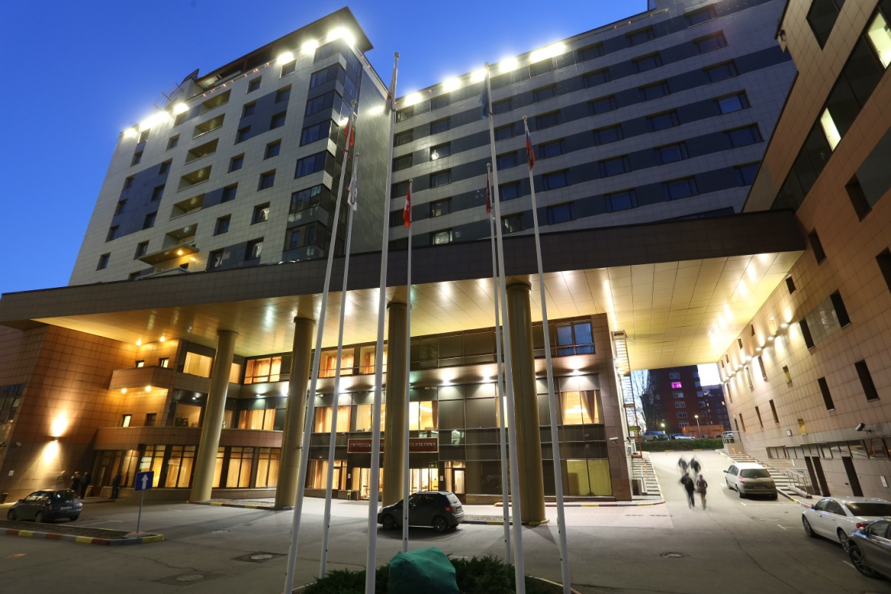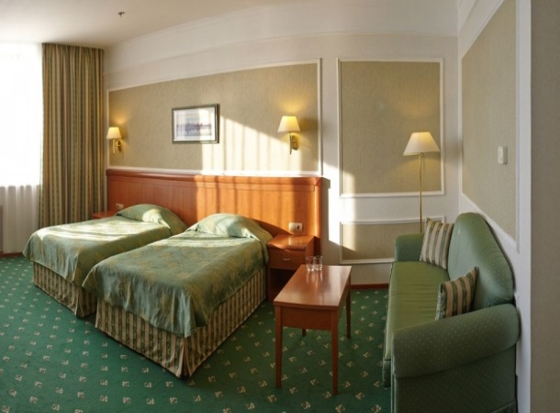

Location Rusakovskaya st. 13 ,5
Metro station Sokolniki

SPECIAL OFFER:
(Price is per room + breakfast)
Type of rooms | Price for room
Standard ( Single) | 55 euro /3 900 rub
Standard ( Double ) | 65 euro / 4 700 rub
Standard (Triple ) | 95 euro / 6 900 rub

Special offers on accommodation of participants
XVI WORLD DANCE OLYMPIADS
in the hotel «IZMAYLOVO"» (GAMMA BILD.)

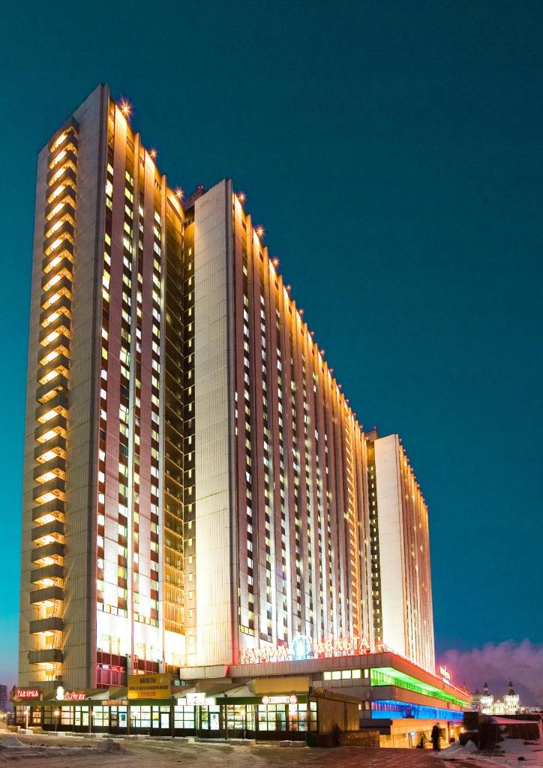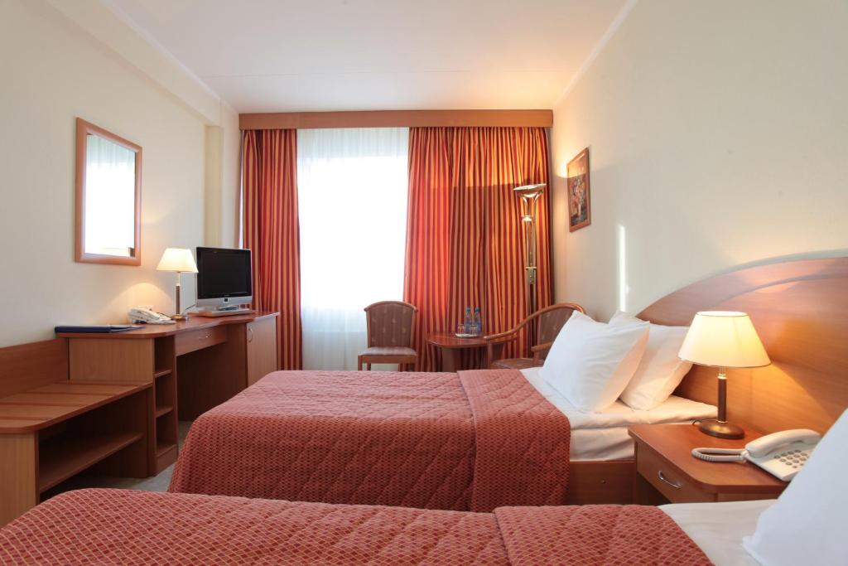

Location: Izmailovskoe Shosse 71, Moscow,
Metro Station Partizanskaya

SPECIAL OFFER:
(Price is per room with breakfast/ without breakfast)
Type of rooms | Price for room (with breakfast ) | Price for room (without breakfast )
Standard ( Single) | 45 euro/ 3 150 rub | 35 euro /2 500 rub
Standard ( Double ) | 55 euro / 4 000 rub | 40 euro / 2 700 rub

Special offers on accommodation of participants
XVI WORLD DANCE OLYMPIADS
in the hotel «holiday inn Suschevsky»

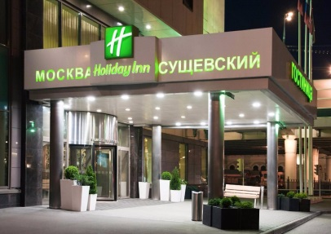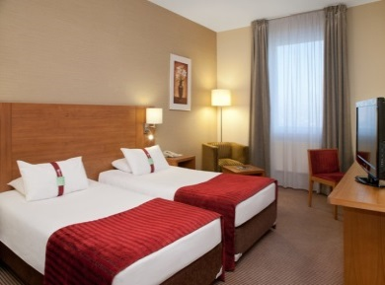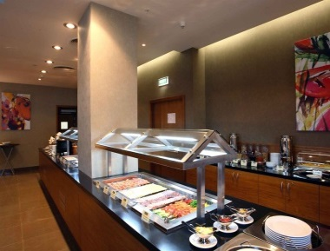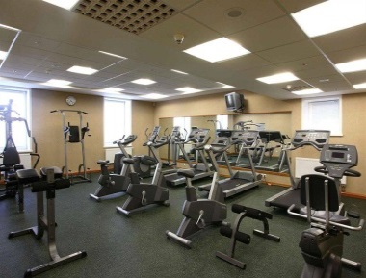

Location: Suschevsky Val 74, Moscow
Metro Station Rizhskaya – 700 м, 5 km to Red Square

SPECIAL OFFER:
(Price is per room with breakfast)
Type of rooms | Price for room (with breakfast )
Standard ( Single) | 45 euro / 3 300 rub
Standard ( Double ) | 50 euro / 3 500 rub

Special offers on accommodation of participants
XVI WORLD DANCE OLYMPIADS
in the hotel «sokolniki»

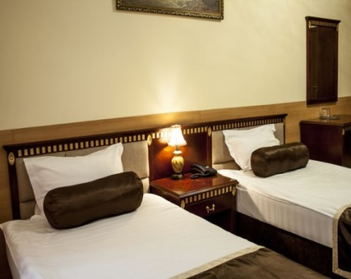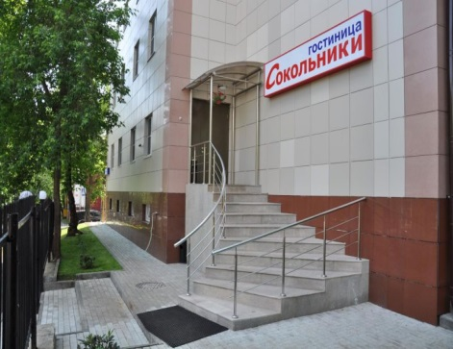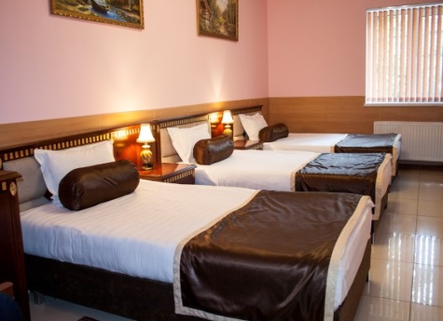

Location: 1st Boevskaya Str. 6, Moscow
Metro Station Sokolniki

SPECIAL OFFER:
(Price is per room + breakfast)
Type of rooms | Price for room  (with breakfast )
Standard ( Single) | 50 euro / 3 500 rub
Standard ( Double ) | 55 euro / 4 000 rub
Standard (Triple ) | 75 euro/ 5 500 rub
Luxe ( Double) | 65 euro / 4 700 rub

Special offers on accommodation of participants
XVI WORLD DANCE OLYMPIADS
in the hotel « NETIZEN HOTEL/HOSTEL »

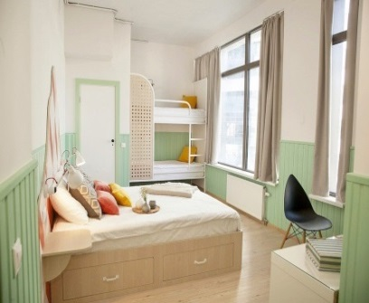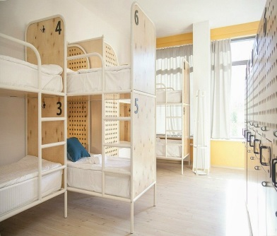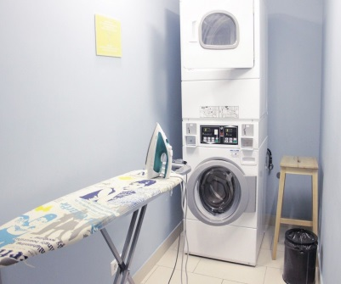

Location: Boulevard of Enthusiasts, 2, Moscow.
If you are travelling by car or ordering a taxi use address 7 Mezhdunarodnaya for convenience
Metro Station Rimskaya

SPECIAL OFFER:
(Price is per room)
Type of rooms | Price for room  (with breakfast )
Bed in dormitory | 13 euro /1 000 rub
Standard double/twin room | 50 euro / 4 200 rub
Family room (6 persons) | 85 euro / 6 200 rub

Special offers on accommodation of participants
XVI WORLD DANCE OLYMPIADS
in the hotel «ZOLOTOY KOLOS»

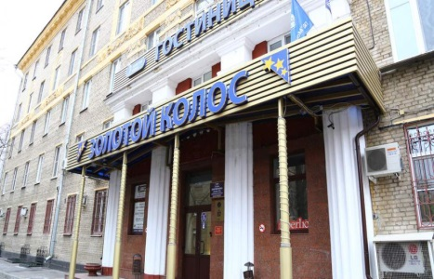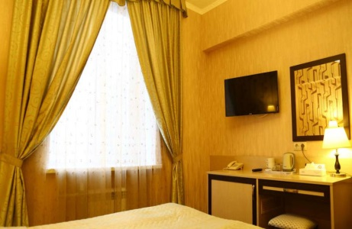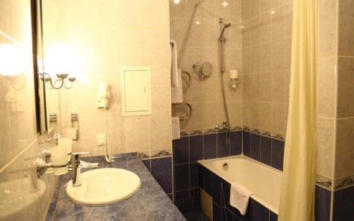

Location: 15 Yaroslavskaya St., Building 3, Moscow
Metro Station “VDNKh” (on the orange line)

SPECIAL OFFER:
(Price is per room + breakfast)
Вид номера | Стоимость
Standard ( Twin) | 40 euro /3 000 rub
Standard ( Double ) | 40 euro /3 000 rub
2-room Comfort with one Double bed and extra bed | 60 euro /4 300 rub

Special offers on accommodation of participants
XVI WORLD DANCE OLYMPIADS
in the mini-hotel «numera»

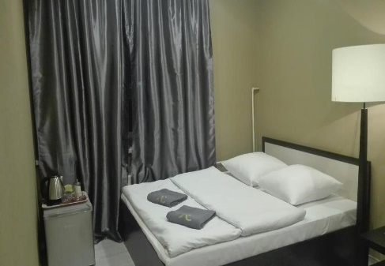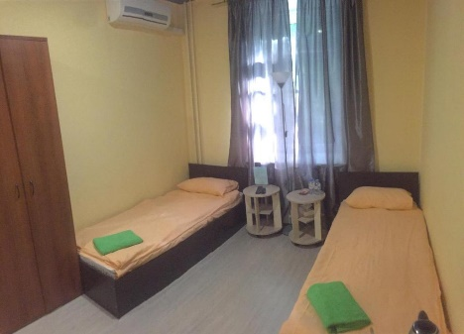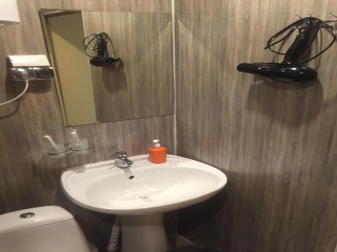
Location: st. Stromynka, 11; 3rd entrance, Moscow
Metro Station Sokolniki

SPECIAL OFFER:
(Price is per room )
Вид номера | Стоимость
Standard ( Twin) | 35 euro / 2 300 rub
Standard ( Double ) | 35 euro /2 200 rub
Comfort with one Double bed and extra bed | 45 euro /3 200 rub

Applications will be accepted until April 12, 2019.
BY EMAIL: Elena Makarova elena.314@hotmail.com, elenavbrr@yandex.ru
indicating in the subject "Reservation hotel « …… »
If you didn`t get the order confirmation during 2 running days, please repeat your demand

Application form for reservation:

Date of reservation - "___", the ________________2019
Please book rooms in Hotel « »
Team name:
Leader`s name/surname:
Phone:
E-mail:
Last Name, First Name  (Latin spelling) | Date / Time of check-in | Date / Time of check-out | Accomodation type:  single, double,triple

Total:
Single______ Double______ Triple_______
Number of people:________________
In addition
(to be completed if necessary):
This application form is the guarantee of 100% prepayment for all services. It should be done before 12, April 2019. After 12, April 2019 if the prepayment haven`t been done, the application will be canceled.
Change and cancellation of reservation is possible no later than 10 days before check-in (till 17.00) by
e-mail. If you didn`t get the order confirmation during 4 running days, please repeat your demand.

