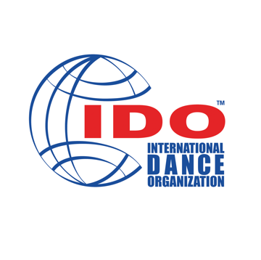
IDO ADJUDICATORS CV FORM

PERSONAL INFORMATION

First Name: |  |  |  | Surname:
E-mail: |  | Date of Birth: |  |  | Country of Citizenship:
Mobile Number: |  |  |  | IDO ID Number, as listed in J-DIES:
EDUCATION / PROFESSIONAL HISTORY

List of education, including academic and dance training from childhood to present:

Areas of expertise, including dance disciplines, you are qualified to judge:

List of professional credits, including academic, performance, and teaching:

Professional associations (member of…):

Organizing experience:

Adjudication experience:

Dance Experience:

Special accomplishments:

JUDGING REQUIREMENTS AND REIMBURSEMENT AGREEMENT

1. | Are you familiar with the IDO judging procedures and systems that are used at various IDO events? |  |  |  |  |  | Yes | No
2. | Are you aware of all rules infractions that may occur during an IDO event? |  |  |  |  |  | Yes | No
3. | Do you agree to follow and adjudicate according to IDO Dance Sport Rules and Regulations? |  |  |  |  |  | Yes | No
4. | Do you agree to follow the adjudicator’s code of conduct and to work ethically and honestly, following all instructions given to you by the Chairperson of Judges at IDO events? |  |  |  |  |  | Yes | No
5. | Do you agree to the IDO Fee structure to perform your adjudication services? |  |  |  |  |  | Yes | No
6. | Do you understand the IDO procedures and regulations regarding the payment of expenses? |  |  |  |  |  | Yes | No
7. | Do you understand that you will not be paid for travel days, except in the case of special circumstances or as defined and agreed to by the IDO before any travel arrangements being made? |  |  |  |  |  | Yes | No
8. | Do you speak and understand English?  If not, are you willing to provide an interpreter at your own expense? |  |  |  |  |  | Yes  Yes | No  No
SIGNATURE

I agree that my personal data, these are data like given name, family name, date of birth, address, education, membership of a national organization, type of membership, enrollments to competitions and championships will be processed for the use of the International Dance Organization (IDO).

I agree that the collection and the application of my contact data like phone number and email address will be used to inform me about international competitions, championships, dance camps, and dance events. This agreement can be withdrawn at any time by emailing GDPR@ido-dance.com.

I agree that all pictures and videos on which I will be part of at competitions and championships of the IDO, done by professional agents or officials of the IDO, can be used for IDO public relations of the IDO as deemed appropriate by the IDO.

I agree that the material can be printed on IDO flyers, used on the IDO homepage and social media, and used for live-stream, or any other purpose as deemed appropriate by the IDO.

I do not connect this with any rights (i.e., fee for the pictures and videos) for commercial purposes. This agreement can be withdrawn at any time by emailing GDPR@ido-dance.com. In this case, all pictures will be removed from the IDO homepage as well as from IDO social media and the internet to the extent possible by the IDO.

I understand and agree that following Article 49(1)(a) and Article 49(1)(c) of Regulations about data protection outside EU/EEA about transferring data, personal data cannot be protected in the same way as in EU/EEA countries.

I hereby agree that I will not work against the International Dance Organization (IDO) and its positive image, both on national and international levels.

I hereby agree that, if asked by the International Dance Organization (IDO), I will return my license book, following the IDO procedures and rules.
Member of IDO National Member Organization:

Signature: |  |  |  |  |  | Date:

For any questions or further clarification please contact the Adjudication Director.

Please send this form via E-mail to the IDO Adjudication Director at:

adjudication@ido-dance.com

